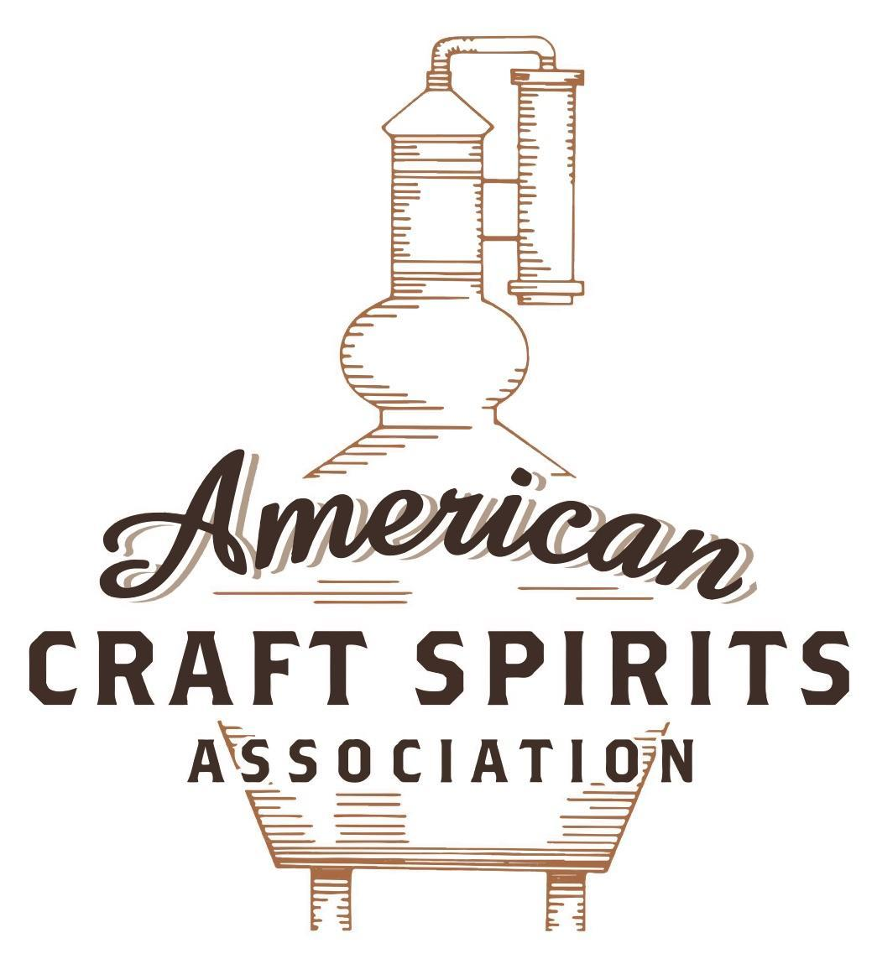
Spirits DtC Shipping Guide

This guide summarizes the direct-to-consumer shipping rules for distilleries in all 50 states and D.C. and also addresses the measures state governments have taken to ease delivery and shipping restrictions during the COVID-19 pandemic.

DtC Quick Guide Comparison

Out-of-State Distilleries  Can Ship Into State? |  |  |  | In-State Distilleries  Can Ship Within State?
State | Yes | No |  | State | Yes | No
AL |  | X |  | AL |  | X
AK | X |  |  | AK | X
AZ | X |  |  | AZ | X
AR |  | X |  | AR |  | X
CA |  | X* |  | CA |  | X*
CO |  | X |  | CO |  | X
CT |  | X* |  | CT |  | X
DE |  | X |  | DE |  | X
DC | X |  |  | DC | X
FL |  | X |  | FL |  | X
GA |  | X |  | GA |  | X
HI |  | X* |  | HI |  | ?*
ID |  | X |  | ID |  | X
IL |  | X* |  | IL |  | X*
IN |  | X |  | IN |  | X
IA |  | X* |  | IA |  | X*
KS |  | X |  | KS |  | X
KY | X |  |  | KY | X
LA |  | X |  | LA |  | X
ME |  | X* |  | ME |  | X*
MD |  | X |  | MD |  | X
MA |  | X |  | MA |  | X
MI |  | X |  | MI |  | X
MN |  | X |  | MN |  | X
MS |  | X |  | MS |  | X
MO |  | X |  | MO |  | X
MT |  | X |  | MT |  | X
NE | X |  |  | NE | X
NV |  | X* |  | NV |  | X
NH | X |  |  | NH |  | X*
NJ |  | X* |  | NJ |  | X*
NM |  | X |  | NM |  | X
NY |  | X* |  | NY |  | X*
NC |  | X |  | NC |  | X
ND | X |  |  | ND | X
OH |  | X |  | OH |  | X
OK |  | X |  | OK |  | X
OR |  | X |  | OR | X
PA |  | X* |  | PA |  | X
RI |  | X* |  | RI |  | X
SC |  | X |  | SC |  | X
SD |  | X |  | SD |  | X
TN |  | X |  | TN |  | X
TX |  | X |  | TX |  | X
UT |  | X |  | UT |  | X
VT |  | X |  | VT |  | X
VA |  | X |  | VA |  | X
WA |  | X* |  | WA | X
WV |  | X* |  | WV |  | X*

WI |  | X |  | WI |  | X
WY |  | X |  | WY |  | X

Notes:
*CA: If passed and signed into law, Senate Bill 620 would allow licensed distilled spirits producers in states other than California and licensed distilled spirits manufacturers or craft distillers in California who obtain distilled spirits direct shipper permits to ship directly to consumers in California
*CT: Consumers with appropriate permit may receive alcohol shipments
*HI: Consumers with appropriate permit may receive alcohol shipments; If passed and signed into law, Senate Bill 65 would allow licensed distilled spirits manufacturers in Hawaii and in states other than Hawaii who obtain direct shipper permits to ship directly to consumers in Hawaii
*IL: If passed and signed into law, Senate Bill 0532 would allow licensed distilled spirits producers in Illinois and in states other than Illinois who obtain distillery shippers’ licenses to ship directly to consumers in Illinois
*IA: If passed and signed into law, House File 639 would allow native distilled spirits manufacturers in Iowa and in states other than Iowa who obtain direct shipper permits to ship directly to consumers in Iowa and to consumers in states other than Iowa
*ME: If passed and signed into law, Legislative Document 1358 would allow distilleries outside of Maine with current manufacturer licenses and distilleries licensed in Maine who obtain spirits direct shipper licenses to ship directly to consumers in Maine
*NJ: (1) If passed and signed into law, Assembly Bill 3167 would allow a craft distillery licensees to ship no more than 9 liters of distilled spirits to a consumer in New Jersey; (2) If passed and signed into law, Senate Bill 3020 would allow craft distillery licensees in New Jersey or in states other than New Jersey to ship no more than 20 liters of distilled spirits to a consumer in New Jersey via common carrier
*NV: Licensed individuals can import one gallon per month of spirits for personal use and the out-of-state supplier must pay excise tax
*NH: If passed and signed into law, Senate Bill 125 would allow licensed liquor manufacturers who obtain direct to consumer shipping permits from the commission to ship directly to consumers in New Hampshire
*NY: Consumer may import up to 90L of liquor per year for personal use without a license; If passed and signed into law, Assembly Bill 3275 would allow licensed liquor manufacturers in states other than New York and licensed distillers and farm distillers in New York to ship no more than thirty-six cases (no more than nine liters per case) of liquor to consumers in New York
*PA: Consumer may place a special liquor order and distiller must ship to a PLCB-operated store
*RI: Distiller can only ship to customer if order was personally placed by customer at distiller's premises
*WA: If passed and signed into law, House Bill 1432 would allow licensed spirits manufacturers in states other than Washington to ship spirits to consumers in Washington
*WV: Distilleries, mini-distilleries, or micro-distilleries licensed in West Virginia or a state other than West Virginia who obtain private direct shipper licenses to ship to a consumer in West Virginia, however the shipments must be made to a retail liquor outlet
IOWA
Shipment Outbound – Yes, the manufacturer’s and native distillery licenses allow licensees to ship out of state to customers if the purchaser has the right to receive it in their state (IA Rule 185—5.3(2)).
Shipment Inbound – No. The division has exclusive control within the state as purchaser of all alcoholic liquor sold by distilleries within the state or imported (IA Code, § 123.22). Shipments can only be made to the state warehouse or to receiving points designated by Iowa’s administrator (IA Rule 185—8.2(1)).
Shipment Intra-state – No. Native distilleries can only sell for on-premises consumption (IA Code, § 123.30(c)).
COVID-19 Measures – Licensees and permittees authorized to sell liquor in original unopened containers for off-premises consumption may deliver to a home. H.F. 766, signed and enacted into law on May 10, 2021, authorizes the delivery of liquor, wine, or beer by a licensee or permittee, an employee of the licensee or permittee, or a third party if the licensee or permittee has entered into a written agreement with the third party authorizing the third party to act as an agent of the licensee or permittee for the purpose of delivering alcoholic liquor, wine, or beer.
H.F. 766 Link: https://www.legis.iowa.gov/legislation/BillBook?ga=89&ba=HF766
Citation (shipment)
Iowa Code
§ 123.22 State monopoly.
A distillery shall not sell alcoholic liquor within the state to any person but only to the division, except as otherwise provided in this chapter. This section vests in the division exclusive control within the state as purchaser of all alcoholic liquor sold by distilleries within the state or imported, except beer and wine, and except as otherwise provided in this chapter.
Link: https://www.legis.iowa.gov/docs/code/123.22.pdf
§ 123.30 Liquor control licenses — classes.
3. Liquor control licenses issued under this chapter shall be of the following classes:
c. Class “C”.
(3) A class “C” native distilled spirits liquor control license may be issued to a native distillery but shall be issued in the name of the individuals who actually own the business and shall only be issued to a native distillery which, combining all production facilities of the business, produces and manufactures not more than one hundred thousand proof gallons of distilled spirits on an annual basis. The license shall authorize the holder to sell native distilled spirits manufactured on the premises of the native distillery to patrons by the individual drink for consumption on the premises and mixed drinks or cocktails for consumption off the premises subject to the requirements of section 123.49, subsection 2, paragraph “d”. All native distilled spirits sold by a native distillery for on-premises consumption and mixed drinks or cocktails sold for consumption off the premises shall be purchased from a class “E” liquor control licensee in original unopened containers.
Link: https://www.legis.iowa.gov/docs/code/123.30.pdf
§ 123.41 Manufacturer’s license — alcoholic liquor.
1. Each completed application to obtain or renew a manufacturer’s license shall be submitted to the division electronically, or in a manner prescribed by the administrator, and shall be accompanied by a fee of three hundred fifty dollars payable to the division. The administrator may in accordance with this chapter grant and issue to a manufacturer a manufacturer’s license, valid for a one-year period after date of issuance, which shall allow the manufacture, storage, and wholesale disposition and sale of alcoholic liquors to the division and to customers outside of the state.
Link: https://www.legis.iowa.gov/docs/code/123.41.pdf
§ 123.43A Native distilleries.
1. Subject to rules of the division, a native distillery holding a class “A” native distilled spirits license issued pursuant to section 123.43 may sell or offer for sale native distilled spirits. As provided in this section, sales of native distilled spirits manufactured on the premises may be made at retail for off-premises consumption when sold on the premises of the native distillery that manufactures native distilled spirits. All sales intended for resale in this state shall be made through the state’s wholesale distribution system.
2. A native distillery shall not sell more than one and one-half liters per person per day, of native distilled spirits on the premises of the native distillery. However, a native distillery which, combining all production facilities of the business, produces and manufactures not more than one hundred thousand proof gallons of native distilled spirits on an annual basis, may sell not more than nine liters per person per day, of native distilled spirits. In addition, a native distillery shall not directly ship native distilled spirits for sale at retail. The native distillery shall maintain records of individual purchases of native distilled spirits at the native distillery for three years.
3. A native distillery shall not sell native distilled spirits other than as permitted in this chapter and shall not allow native distilled spirits sold for consumption off the premises to be consumed upon the premises of the native distillery. However, native distilled spirits may be tasted pursuant to the rules of the division on the premises where fermented, distilled, or matured, when no charge is made for the tasting.
4. The sale of native distilled spirits to the division for wholesale disposition and sale by the division shall be subject to the requirements of this chapter regarding such disposition and sale.
7. A native distillery may sell the native distilled spirits it manufactures to customers outside the state.
Link: https://www.legis.iowa.gov/docs/code/123.43A.pdf
Iowa Rules
185—5.3(123) Licensed manufacturers and wholesalers.
5.3(1) License required. A separate manufacturer’s or wholesaler’s license shall be required for each place of business of the holder.
5.3(2) To whom liquor may be sold outside the state of Iowa. The holder of a manufacturer’s or wholesaler’s license shall not sell alcoholic liquor outside the state of Iowa, except to a purchaser having the legal right to buy and receive it from the seller at the place of sale and place of delivery, respectively.
5.3(3) Proof of right to purchase. Before making a sale to a purchaser other than the division, a licensed manufacturer or wholesaler shall require the purchaser to produce and exhibit for inspection
proof of the right to purchase alcoholic liquor according to the laws of the purchaser’s own state.
Link: https://www.legis.iowa.gov/docs/iac/rule/08-08-2012.185.5.3.pdf
185—8.2(123) Rules and regulations as between shippers and this division.
8.2(1) Shipment into state. Shipments of alcoholic liquors can only be made into the state of Iowa by suppliers. Shipments can only be made to the state warehouse, 1918 S.E. Hulsizer, Ankeny, Iowa 50021, or to receiving points designated by the administrator.
Link: https://www.legis.iowa.gov/docs/iac/chapter/10-07-2020.185.7.pdf
Citation (COVID-19)
Regulatory Bulletin
Third-Party Delivery of Alcoholic Beverages (July 1, 2021)
Iowa Code section 123.46A outlines the regulations regarding the delivery of alcoholic beverages.
What can be delivered?
- Deliveries shall be limited to alcoholic beverages authorized by the licensee’s or permittee’s license or permit.
  - Alcoholic liquor, wine, or beer in original unopened containers for consumption off the licensed premises.
  - Wine, beer, or mixed drinks or cocktails for consumption off the licensed premises in a container other than the original container only if the container other than the original container has been sold and securely sealed in compliance with Iowa Code chapter 123 and Iowa Administrative Code 185.
Can alcohol be shipped directly to a consumer?
- Wine may be shipped directly to a consumer by a wine manufacturer who has obtained a wine direct shipper permit pursuant to Iowa Code section 123.187.
- No other alcoholic beverages can be shipped directly to a consumer in Iowa.
Where can alcohol be delivered?
- Alcohol may be delivered to a home, another licensed premises if there is identical ownership of the premises by the licensee or permittee, or other designated location in this state.

When can alcohol be delivered?
- Deliveries shall occur between 6:00 a.m. and 10:00 p.m. Monday through Sunday.
Who can deliver?
- Licensees and permittees authorized to sell alcoholic liquor, wine, or beer in original unopened containers for consumption off the licensed premises.
- Licensees and permittees authorized to sell wine, beer, or mixed drinks or cocktails for consumption off the licensed premises in a container other than the original container.
- A third party that has a written agreement with a licensee or permittee who is authorized to sell alcoholic liquor, wine, or beer in original unopened containers or wine, beer, or mixed drinks or cocktails in a container other than the original container for off premises consumption.
  - The licensee or permittee shall submit to the division a list of third-party entities it has authorized to act as its agent for the purpose of delivering alcoholic beverages.
  - The licensee or permittee shall provide the division with amendments to the list as necessary to ensure the division possesses an accurate, current list.

Other considerations:
- Payment for the alcoholic beverages shall be received by the licensee or permittee at the time of order.
- Delivery personnel shall be twenty-one years of age or older.
- Alcoholic beverages delivered pursuant to Iowa Code section 123.46A shall be for personal use and not for resale.
- Deliveries shall only be made to persons in this state who are twenty-one years of age or older.
- Valid proof of the recipient’s identity and age shall be obtained at the time of delivery, and the signature of a person twenty-one years of age or older shall be obtained as a condition of delivery.
- Deliveries shall not be made to a person who is intoxicated or is simulating intoxication.
- Licensees and permittees shall maintain records of deliveries which include the quantity delivered, the recipient’s name and address, and the signature of the recipient of the alcoholic beverages. The records shall be maintained on the licensed premises for a period of three years.

CONCLUSION:
- The passage of House File 766 did not change who can deliver alcohol pursuant to Iowa Code section 123.46A. House File 766 changed how those authorized to deliver alcohol pursuant to Iowa Code section 123.46A may deliver.
- A native distillery holding both an ND and LCN license may deliver mixed drinks or cocktails and may enter into an agreement with a third party to deliver mixed drinks or cocktails.
- A native brewery holding both a BAN and BB permit may deliver beer and may enter into an agreement with a third party to deliver beer.
- A native winery holding both a WAN and WCN permit may deliver native wine and beer and may enter into an agreement with a third party to deliver native wine and beer.
Link: https://abd.iowa.gov/sites/default/files/media/file/2021-07/regulatory-bulletin-third-party-delivery-of-alcoholic-beverages.pdf
123.46A Delivery of alcoholic beverages by retailers.
1. Licensees and permittees authorized to sell alcoholic liquor, wine, or beer in original unopened containers for consumption off the licensed premises may deliver alcoholic liquor, wine, or beer to a home, another licensed premises if there is identical ownership of the premises by the licensee or permittee, or other designated location in this state. Deliveries shall be limited to alcoholic beverages authorized by the licensee’s or permittee’s license or permit.
2. All deliveries of alcoholic liquor, wine, or beer shall be subject to the following requirements and restrictions: a. Payment for the alcoholic liquor, wine, or beer shall be received by the licensee or permittee at the time of order.
b. Orders for deliveries may be taken by the licensee or permittee between the hours of 2:00 a.m. and 6:00 a.m. on a day other than Sunday, and orders for deliveries may be taken between the hours of 2:00 a.m. and 8:00 a.m. on a Sunday provided the licensee or permittee has been granted the privilege of selling alcoholic liquor, wine, or beer on Sunday, notwithstanding any provision of section 123.49, subsection 2, paragraph “b”, to the contrary.
c. Alcoholic liquor, wine, or beer delivered to a person shall be for personal use and not for resale.
d. Deliveries shall only be made to persons in this state who are twenty-one years of age or older.
e. Deliveries shall not be made to a person who is intoxicated or is simulating intoxication.
f. Deliveries shall occur between 6:00 a.m. and 10:00 p.m. Monday through Saturday, and between 8:00 a.m. and 10:00 p.m. Sunday.
g. Delivery of alcoholic liquor, wine, or beer shall be made by the licensee or permittee, or the licensee’s or permittee’s employee, and not by a third party.
h. Delivery personnel shall be twenty-one years of age or older.
i. Deliveries shall be made in a vehicle owned, leased, or under the control of the licensee or permittee.
j. Valid proof of the recipient’s identity and age shall be obtained at the time of delivery, and the signature of a person twenty-one years of age or older shall be obtained as a condition of delivery.
k. Licensees and permittees shall maintain records of deliveries which include the quantity delivered, the recipient’s name and address, and the signature of the recipient of the alcoholic liquor, wine, or beer. The records shall be maintained on the licensed premises for a period of three years.
l. Orders delivered to another licensed premises shall contain only those alcoholic beverages authorized for sale by the liquor control license or retail wine or beer permit covering the premises to receive the delivery.
m. Orders delivered to another licensed premises shall be fulfilled using the alcoholic beverages inventory owned by the licensee or permittee who received the order for delivery. If the recipient refuses or fails to pick up the delivery, or is ineligible to receive the delivery, the alcoholic beverages shall be returned to the licensee or permittee who fulfilled the order.
3. A violation of this section or any other provision of this chapter shall subject the licensee or permittee to the penalty provisions of section 123.39.
4. Nothing in this section shall impact the direct shipment of wine as regulated by section 123.187.
Link: https://www.legis.iowa.gov/docs/code/123.46A.pdf

The American Craft Spirits Association (ACSA) is working diligently to give our members and industry partners relevant, current updates on statutes and regulations impacting production, sale and distribution of spirits. With the declaration of the novel coronavirus (COVID-19) in early 2020, many states have issued temporary policy changes or longer-term modernization of alcohol beverage laws. State statutes, regulations created by the state alcohol regulatory authority, as well as any other relevant guidance provided by such authorities (such as advisories, opinions, bulletins, etc.) were reviewed in creation of this document. No city or county ordinances were reviewed. Distillers should be aware that even in states where direct shipping is permissible, always remember to avoid shipping to dry counties. Please consult with your state guild or alcohol beverage authority for the most up-to-date information. This content is intended for educational and informational purposes only. ACSA's pro bono law firm of Malkin Law P.A. provided the core content found in this comprehensive overview of the spirits distribution after COVID-19. It was completed in August 2021 and will be updated regularly. If you have updates you would like to provide, please send to legislation@americancraftspirits.org or directly to the law firm at: ryan@malkin.law / malkin.law. Thank you.
H.F. 639, introduced on February 23, 2021, would allow a manufacturer of native distilled spirits licensed or permitted pursuant to laws regulating alcoholic beverages in another state to apply for a direct shipper permit. All shipments must be made through the state’s wholesale distribution system. The bill is in committee. Link: https://www.legis.iowa.gov/docs/publications/LGI/89/attachments/HF639.html
H.F. 639, introduced on February 23, 2021, would allow a manufacturer of native distilled spirits licensed or permitted pursuant to laws regulating alcoholic beverages in Iowa to apply for a direct shipper permit. All shipments must be made through the state’s wholesale distribution system. The bill is in committee. Link: https://www.legis.iowa.gov/docs/publications/LGI/89/attachments/HF639.html

